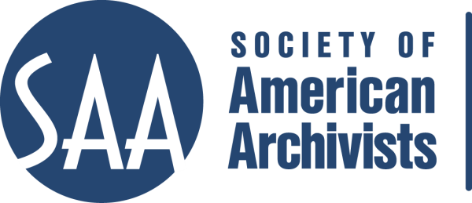
CE Workshop Evaluation Form
Arrangement and Description Track

Workshop Evaluation Form:

Title | Ethical Problem Solving
Reviewer: | Martin T. Olliff
Directions:
- Quantitative: Each item below begins with a bolded statement. Score each with a 1-5 ranking to indicate your assessment of the veracity of that statement based on your review of workshop overviews/agendas, evaluations, and other materials.
- Qualitative: In the comments section for each item below, please respond to the additional questions posed and any related issues that this workshop raises for you.
- Provide any additional assessments or comments not relevant to one of the specific, numbered areas in the space provided following the table.

Please place an “x” in the appropriate column, use 1=low, undesirable, to 5=high, excellent. | 1 | 2 | 3 | 4 | 5
1. Does the content appeal to its specified audience? Does it indicate specific categories of archivists and/or levels of expertise to assist potential participants in determining the workshop's relevance for them?  Comments: “All practicing archivists” is the stated audience, and the workshop topic should appeal to us all. |  |  |  |  | X
2. To what extent does the subject matter reflect current archival practices and theory commonly accepted in the profession?  Comments: Benedict was an authority. She incorporated her most recent work. Any updates should use the latest scholarship and SAA documents. |  |  |  |  | X
3.. How relevant/appropriate are the teaching and delivery methodologies (lecture, video, PowerPoint, exercises, film, audiotape, discussion, simulation, case study, opportunities for in-course feedback, etc.) to the articulated goals and objectives, and to the content?"
Comments: Not possible to tell from available documentation; appears to rely on guided discussion that is an appropriate pedagogical tool in this circumstance.
4. How workable is the time line or agenda for the course? Is there sufficient detail to indicate how the workshop will evolve? Does it allow sufficient time for active engagement between course participants and the instructor(s)?  Comments: The bare-bones agenda lets a participant understand the general direction, but by itself is not sufficient for a thorough understanding of what will occur /what to expect in the actual workshop. |  |  | X

5. To what degree does the list of assigned readings support the content of the proposal?  Comments: There is a 59-page reading that, I suspect, is a draft of part of Benedict’s Ethics and the Archival Profession: Introduction and Case Studies, but it is unidentified and does not appear as an assignment in the documentation. Regardless, the course requires updating to deal with the most recent SAA Code of Ethics update and new writings on archival ethics. |  | X
6. Does the presentation support the Learning Outcomes in the descriptions?  Comments: Given the quality of the presenter, I’d say yes, but it’s not possible to tell from the documentation. | X

A&D Track Considerations
1.Does this content bridge, enhance, and/or build on other workshops (If so, please name) | Ethics should be part of all courses. Indeed, at some point all but the most technical courses have a component concerning ethics or have the potential to incorporate concerns about ethics. Having a distinct ethics workshop ensures a solid, systematic, and programmatic foundation for best practices across the curriculum.
2.Does this build on other workshops not on the list? | Certainly. ANY workshop that goes concerns relationships of archival offices with any other entity should found its practices on ethics. Therefore, the ethics workshop spans almost every other workshop.
3 Should this be part of the A&D Track? | The Ethics Workshop should be part of every track, though a participant should receive credit in multiple tracks for taking Ethics as a “core course.” Time limits should apply; that is, to receive credit in a track, a participant should take the Ethics Workshop within a very few years of completing the track.
4.Where would this workshop fall in the sequence of an A&D track? | The Ethics Workshop can fall either at the beginning of the A&D track sequence or after a few initial courses. Depending on how it’s taught, it can be the first foundation course or it can come early in the sequence after a participant has some ethical dilemmas arise via discussions in other courses.
Why? | Ethics is a foundation course. All best practices build upon it.
5. What tier does this workshop fall in? (See attached tiers)
6. Target Audience | ALL archivists will benefit from this workshop, though it probably benefits those with a little experience beyond entry-level.
7. Is the suggested prior “experience/knowledge” appropriate? | n/a
8. Learning Outcomes:  Are they appropriate and/or relevant? | n/a
9. What should they be?  Please list learning outcomes. | I am not yet competent to determine learning outcomes for a revised and updated version of this workshop; however, the proper instructor will be able to determine learning outcomes.
10. Can you make suggestions for competencies this workshop would fulfill? | n/a
11. Would parts of the content lend themselves to a different format? | Check one: Webinar: - 30 minute - 90minute In person: - 1/2 day - 1 day - 2 day
12. Which parts?
13. Does it lend itself to repurposing as an audio CD? | n/a
Which parts?

Other comments:
With the SAA updating and revising the Code of Ethics since Karen Benedict developed this workshop, it is time to approach more current authors on ethics to reconstitute the workshop. I do not believe the Education Committee should impose a priori directions or restrictions on a competent instructor but should work with that instructor to create a solid course that fits the parameters of SAA’s Continuing Education best practices.

